PANTS ON FIRE – HOW CLIMATE MISINFORMATION IS SPREAD IN THE BALTIC STATES?
OCTOBER 2023
Ronalds Siliņš

Whether their goal is to amass a following, oppose environmentally friendly policies, or resist what they perceive as “totalitarian global control”, a diverse group of disinformation spreaders has shifted its focus to the topic of climate change. Who comprises this group? Where do they source their talking points? And have they successfully deceived the Baltic population?

WHO IS SPREADING CLIMATE CHANGE MISINFORMATION IN THE BALTICS?
During the last century fossil fuel companies started a disinformation campaign about climate change. With the help of well financed think tanks, “experts” and politicians, they set out to confuse the public about the scientific consensus and the facts surrounding climate change. With the rise of social media, misinformation spread even further and now has been taken up by those outside the fossil fuel sphere, but who still aim to personally benefit from it. For various social media “freedom fighters”, climate change denial is yet another opportunity to increase their following and flaunt their opposition to the establishment, the “West” or fictitious shadow organizations.

“I would call them “superspreaders” – no matter what topic is currently being discussed, they always spread misinformation about that,” says Delfi.ee fact-checker Kaili Malts, while Lithuanian journalist from Delfi Aiste Meidute describes them as routine spreaders of disinformation.

In Latvia, examples include Aivis Vasiļevskis who was previously jailed for justifying Russian war crimes in Ukraine, and the anti-government activist Valentīns Jeremejevs, as well as various anonymous disinformers whose posts are regularly shared by several hundred people.

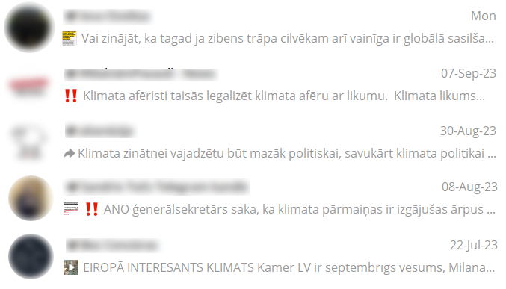
Climate change posts on popular conspiracy Telegram feeds. Source: screenshots from Telegram.

Unlike in Lithuania, Latvia and Estonia have a fair share of politicians that mislead about climate change. Notably, Latvian MPs Aleksandrs Kiršteins and Jānis Dombrava, affiliated with Nacionālā apvienība, a longstanding political party that was excluded in the most recent government reshuffle, have consistently denied human influence on climate change. In a similar vein, during his tenure as minister of agriculture, politician Didzis Šmits (Apvienotais saraksts) referred to the scientific consensus on climate change as “religious” and “arrogant”.

In Latvia, misleading about climate change appears to be done by individual party members, while in Estonia it’s a common tactic for the Estonian Conservative People’s Party (EKRE). According to fact-checkers from Delfi.ee, in the first two summer months alone their members posted false information related to climate change more than 30 times.

WHERE IS DISINFORMATION POSTED AND WHAT ARE ITS SOURCES?
When last summer Re:Check compiled three years worth of fact-checking, we found that climate change didn’t even crack the top five most popular topics. But with the pandemic winding down and the global energy crisis on most people’s minds, climate change and related policies have emerged as a hot topic for disinformation.

According to fact-checkers from all three Baltic countries, the most popular platforms for climate change disinformation are Facebook and Telegram. Despite Meta’s cooperation with independent fact-checkers, every day false information about climate change reaches hundreds of thousands of Facebook users. Occasionally it’s also spread on clickbait websites or conservative media, such as NRA.lv and LA.lv (Latvia), Uued Uudised and Objektiiv (Estonia).

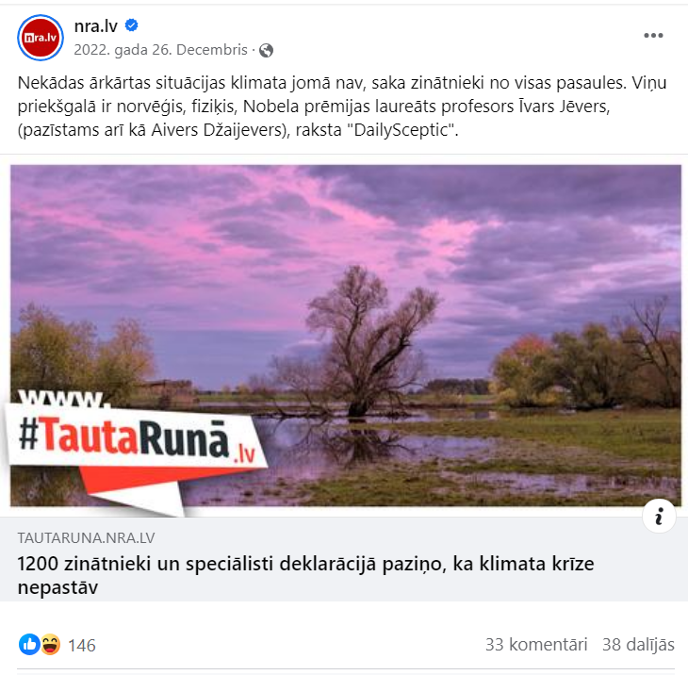

Source: screenshot from Facebook. The post says: There is no climate emergency, say scientists from around the world. They are led by Norwegian Nobel Prize-winning physicist Professor Ivar Giaever, writes the DailySceptic.

Often the misleading content is translated or paraphrased from articles published in English. This is not surprising because – as researchers from University of Bristol note – fossil fuel companies, together with conservative US think-tanks, have set up a well-funded disinformation network that spreads scientifically unsound information and seeks to cast doubt on the credibility of academic literature.

Usually, disinformers don’t list their sources, but on the rare occasion they do it’s never scientific literature. Sometimes they quote Clintel – a climate skeptic organization founded by the former Shell employee Guus Berkhout – or the CO₂ Coalition, which for years has received donations from foundations associated with the oil tycoons, Koch family.

While not popular in the two other Baltic countries, the international activist group Creative Society has taken a foothold in Lithuania and is one of the most cited sources for climate denial. The organization, which often hosts video conferences on climate change and religious topics, regularly spreads lies and has repeatedly been caught manipulating videos to give the impression that scientists agree with their positions.

Climate change lies are similar in all three countries, but they don’t all become popular at the same moments in time. For example, the misleading document titled “Climate Change Declaration”, which supposedly is signed by over 1200 experts, went viral in Lithuania this September, but Re:Check wrote about its misleading content as early as December 2022. In other countries, news of the declaration started circulating even earlier – in September 2022.

„HUMANS HAVE NO IMPACT ON CLIMATE CHANGE“
Almost all climate scientists and their studies confirm that the dramatically fast rise in global average temperatures over the last 150 years is mainly the result of human activity. However, the climate is also changing naturally, and it is this fact that climate skeptics use to mislead that humans have no impact.

Instead they put blame on solar activity or volcanic eruptions alone. On several occasions this false opinion has been repeated, for example, by the previously mentioned Latvian MP Kiršteins.

Sometimes justification or proof is eschewed completely. For example, the former Latvian minister Šmits claimedthat his opinion on man’s supposedly negligible impact on climate is just “common sense”.

Climate misinformation goes hand in hand with ignoring long-term data. For example, how can we be constantly breaking yearly temperature records, if some summer days were cold and it was raining hail? What about Niagara Falls that froze over this year? Where was global warming there? Similarly in July remarked the Estonian MP Monika Helme (EKRE) – what is all this talk about climate change when it is +12°C outside.

Source: screenshot from Facebook. “While getting ready to take the dog for a walk, I checked the thermometer and it’s +12 outside. It’s been raining all day too. And then all this talk about climate warming and water shortages… Soon there will be snow in July.”

In Lithuania in particular, ridicule and defamation of activist Greta Thunberg is very popular. Allegedly, instead of the planet she wants to save banks, this year she’s predicted the end of the world, is transgender and has gained loads of weight. For years personal attacks against her have been used to discredit the threat of climate change.

Source: screenshot from Delfi.lt.

„GREEN ENERGY ISN’T REALLY GREEN“
Another deception tactic is to convince the wider public that policy makers are lying and that green electricity is actually particularly harmful to the climate and environment in general.

Quite the opposite, climate researchers have concluded that, compared to renewables, the extraction and use of fossil fuels produces more greenhouse gasses and therefore warms the planet more. However green energy is not perfect as well; it also harms the environment. Those who oppose greener energy policies tend to present this information in a one-sided way and avoid mentioning the far greater impact of fossil fuels.

A popular example are the social media pictures of birds who’ve perished by running into wind turbine blades. Although there are such cases, a far larger harm to birds

comes from the extraction and use of fossil fuels, which kill almost 20 times more birds per gigawatt hour of energy produced.

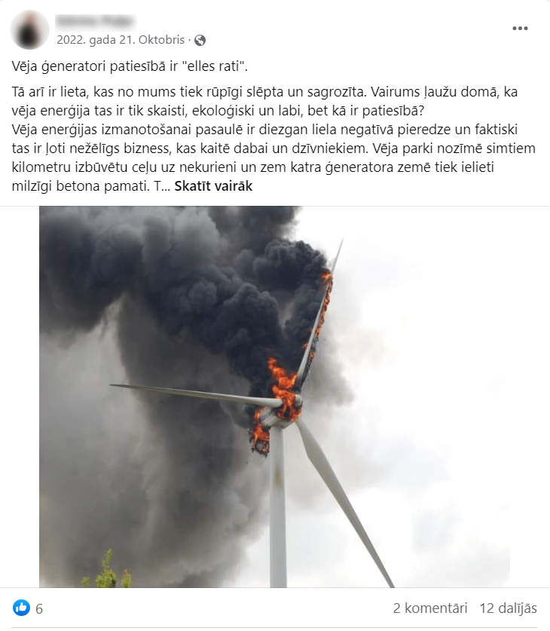
Source: screenshot from Facebook. The post says: In reality, wind generators are “wheels from hell”.

In the Baltic countries, it is also often claimed that renewable energy is neither cost–effective, nor efficient. For example, the previously mentioned Creative Society alleges that over their lifetime wind turbines recoup only 78% of the invested resources. The organization does not provide any evidence and does not even mention which country they’re talking about. However, naming a specific number gives the impression it’s a result of serious research.

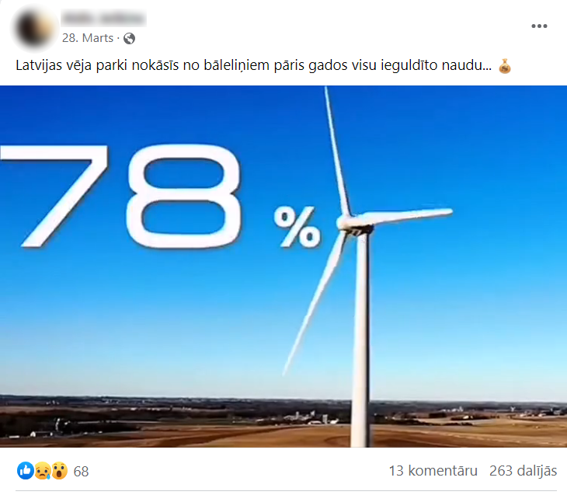
Source: screenshot from Facebook. The post says: In a few years Latvia’s wind farms will skim off all the invested money.

„CLIMATE CHANGE IS A CONSPIRACY FOR PUBLIC CONTROL“
This narrative is shared mainly by the aforementioned super-spreaders, who find evil intentions in almost every initiative or policy. According to them, governments, media and researchers lie about climate change to control humanity. For example, to force it to eat insects or to introduce so-called climate lockdowns. Most likely the use of the word “lockdown” isn’t accidental, but meant to conjure memories of COVID pandemic restrictions.

In the Baltic States, as elsewhere in Europe, such delusions became popular in the first half of this year when the media started talking about the so-called 15-minute cities. What conspiracy theorists see as a tool of ultimate control, instead is an urban planning concept that should provide easy access to everyday services, reduce traffic and make the cities more environmentally friendly.

Source: screenshot from Telegram. The post says: This means you will not be allowed to drive. During climate change lockdowns, you won’t be able to go outside your 15-minute city limits.

Climate policy is also baselessly called a way to reduce the world’s population. It is supposedly aimed at destroying agriculture, forcing people to eat insects, and making them weak, sick and docile. “These powerful elites, like [Klaus] Schwab and others, want to control the world. They want to control everyone. What do they want now? They want fewer people,” a Lithuanian user wrote on Facebook, sowing fears of greener climate policies.

Source: screenshot from Facebook.

WHAT’S BEEN DONE TO COMBAT THIS?
Re:Check asked the Latvian Ministry of Climate and Energy whether it is planning any counter measures to counter climate misinformation or to raise public awareness of popular misconceptions. The ministry called these one of the “most important tasks at the current moment” and pointed to upcoming and already approved project proposals aimed at raising public awareness of “the importance of climate neutrality and resilience”.

Despite the best efforts of disinformers and some politicians, most people in the Baltic states take climate change seriously. The latest Eurobarometer survey (published in 2023) shows that 76–92% see it as a major problem. Compared to the previous survey in 2021, concerns about climate change have risen slightly in Latvia and Lithuania, but in Estonia they have moved in the opposite direction.

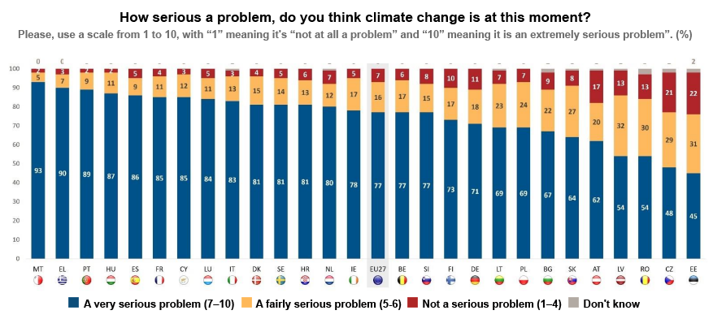
Source: Eurobarometer.
In all three Baltic countries, more than half of the respondents support more public funding for transitioning to what’s called clean energy and see tackling climate change as a priority for improving public health.

